Project Design Phase-II
Data Flow Diagram & User Stories
Date | 26 October 2023
Team ID | 592015
Project Name | Eye disease detection using deep learning
Maximum Marks | 4 Marks

Data Flow Diagrams:

A Data Flow Diagram (DFD) is a traditional visual representation of the information flows within a system. A neat and clear DFD can depict the right amount of the system requirement graphically. It shows how data enters and leaves the system, what changes the information, and where data is stored.
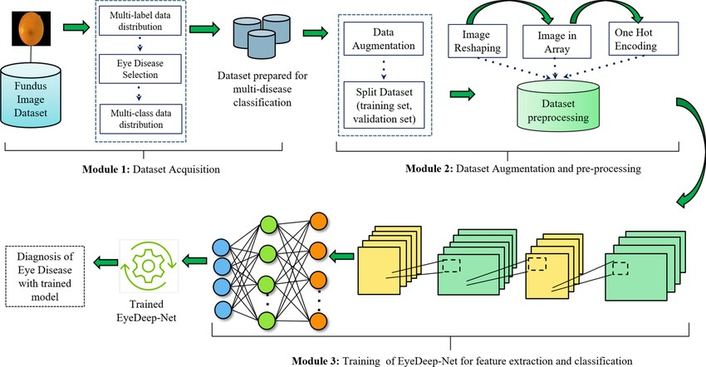

User Stories
User Type | Functional  Requirement  (Epic) | User Story Number | User Story / Task | Acceptance criteria | Priority | Release
Hospitals | Project setup&  infrastructure | USN-1 | Set up the development environment with the requires tools and frameworks to start the eye disease detection project | Successfully configured with all necessary tools and frameworks | High | Sprint-1
Patients | Development environment | USN-2 | Gather a diverse dataset of images containing different types of eye disease for training the deep learning model | Gathered a diverse of images depicting various types of eye images | High | Sprint-1
 | Data collection | USN-3 | Preprocess the collected dataset by resizing images,normalizing pixel values,and splitting it into training and validation sets | Preprocessed the dataset | High | Sprint-1
Reasearch and Academics | Data preprocessing | USN-4 | Explore and evaluate different deep learning architectures (e.g.,CNNs)to select the most suitable model for garbage classification | Exploring various DL models | High | Sprint-2
Non-Governmental  Organizations (NGOs) | model development | USN-5 | train the selected deep learning model using the preprocessed dataset  and monitor its performance on the validation set. | we could do validation | High | Sprint-3
Educational Institutions | Training | USN-6 | implement data augmentation techniques (e.g., rotation, flipping)  to improve the model's robustness and accuracy. | Testing | Medium | Sprint-4
Customer  (Mobile user) | Registration | USN-7 | As a user, I can register for the application by entering my email, password, and confirming my password. | I can access my account / dashboard | High | Sprint-1

